United Slip System (Webbing)
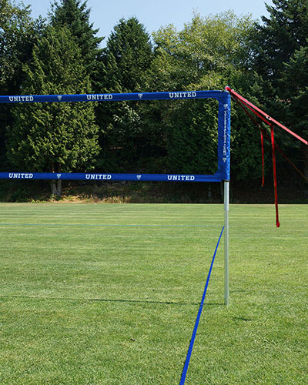

- First set your poles at one of the three height adjustment holes by using the push button to lock them into place.

Poles in longest position is men’s height, the other two adjustment options are for Coed and Women’s.

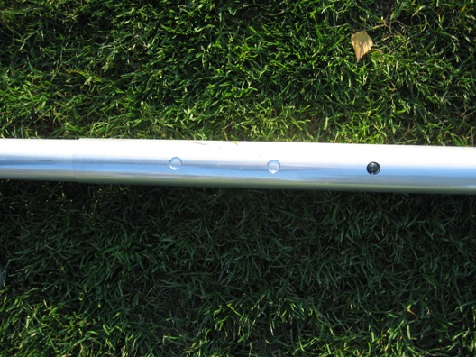

-Please note that the slip system comes pre attached to your volleyball poles! Fully unwrap your net / poles and position to align with your court.

- Find your red guy wire straps and begin attaching them onto your poles by setting up one pole at a time. Stake the first guy wire into the ground through the chain at the bottom of the guywire while the pole is on the ground, making sure that the stake is sunk at a 45 degree angle and driven all down so the head of the stake is below the ground.
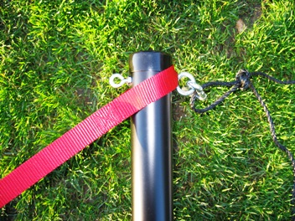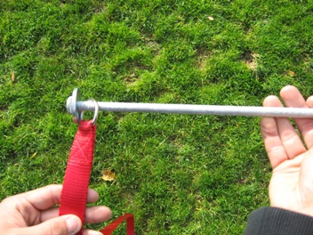
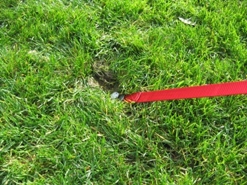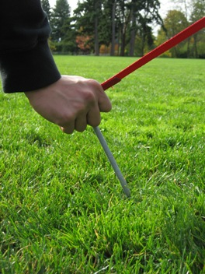
-Be sure that the stake is sunk all the way in to the ground and that the head of the stake sits beneath ground level. Step and repeat for the second guywire on the same side. Stand the pole up leaning it at an angle towards the center of your court. Keep in mind you want your guy wires coming off your pole at 45 degree angles each way so when your pole is stood up with, pull the second guy wire off the top at a 45 degree angle in the other direction.

- Move to your next pole, and do the same. Once you have both poles set up and angled in you can begin tightening your guy wires once side at a time. You may need to adjust the angle of your pole while you tighten your guy wires or after your net is tight. Just pick up the pole just high enough that you can slide the base.

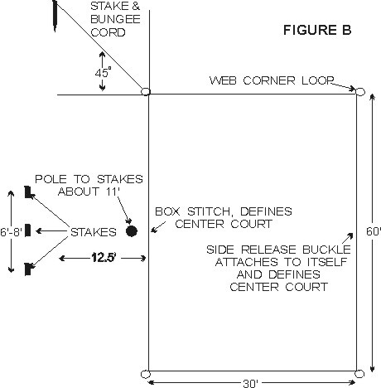
COURT LAYOUT
An ideal spot would be a flat grassy or sandy area free of holes or foreign objects with no limbs or wires overhead. Lay out web lines on the ground to form a rectangle, attach center court, side release buckles on one side of boundary. Other side of center court is marked by a box stitch, use tape if you prefer a larger mark. Attach hooks on bungee cord to each of the four large corner loops of the rectangle. Drive stakes into the ground at a 45-degree angle to the corner loop, or in sand bury them down about a foot at each corner. Do not pull too hard on bungee cord, just enough to get a straight line. Bungee cord will then stretch and snap back into place. Webbing stretches depending on how hard it is pulled on, so the size of your court can very. For set up on dry sand, you may need our #1026 sand kit.
CAUTION: WHEN REMOVING STAKES FROM THE GROUND ALWAYS GRAB BUNGEE CORD UP CLOSE TO STAKE AND PULL STRAIGHT UP OR DIG OUT OF SAND. ALWAYS USE BUNGEE CORD ATTACHED TO STAKE, TO ANCHOR CORNERS. DO NOT ANCHOR THE CORNERS WITH JUST A STAKE ALONE. USE PLASTIC ROLL UP RACK FOR BOUNDARY STORAGE. THE SUN WILL DETERIORATE THE WEBBING, DO NOT LEAVE OUTSIDE UNLESS IN USE AND NEVER LEAVE OUTSIDE OVERNIGHT, IT CAN BE A POTENTIAL HAZARD. WEBBING LINES ON THE GROUND MAY BE TRIPPED OVER, ALWAYS KEEP SMALL CHILDREN AWAY FROM PLAYING AREA, AND INFORM ALL OTHERS OF POTENTIAL HAZARD.

